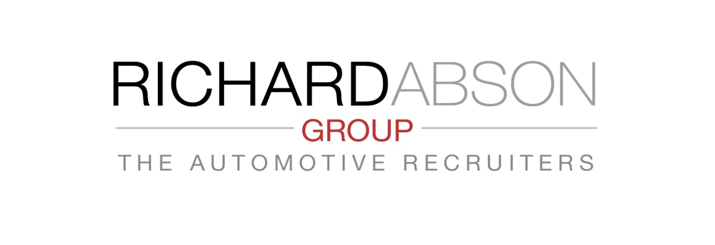Key Elements of a Thorough Recruiting
Process
❖ Part 1 – Job & Candidate Specification.
Every person you employ has a key responsibility in your business –
otherwise, perhaps you do not need them? Therefore when a member of
your team leaves, for whatever reason, and a replacement is required, or
you are taking on additional new staff – it is essential, to review exactly the
job specification (the existing one may need changing), and the candidate
specification before you go to the market to recruit.
It is surprising to us how often clients contact us for recruitment assistance,
but when asked, do NOT have a detailed specification, and are prepared to
operate a ‘hit & miss’ approach to see ‘what’s out there’ in potential
candidate terms. We at The AMR seek the most precise details of job and
candidate specification to find exactly the Right person for each assignment.
Time spent as soon as you know you need a new team member to reevaluate
the Job Specification and Candidate Skills and Competence
will save many hours later in the process, but more importantly avoid you
appointing someone who is ‘best of a poor selection’ or just not right.
Appointing a less effective person in haste will cost you dearly in the
longer run!
Give serious consideration to the Job and People Specification BEFORE you
go to the ‘People Market’
Job Specification - Consider :
➢ Why did the incumbent person leave?
➢ Did you carry out an Exit Interview to determine if there are any
problems concerning the position that you were not aware of?
➢ Has the job changed during the leaver’s occupancy – does it now
require a different skill set?
➢ How well did the leaver fulfil the job?
Draw up a detailed Job Description that covers every aspect of
all responsibilities & priorities.
Candidate Specification- Consider :
➢ The practical skill set and experience the job demands.
➢ What specific technical or educational qualifications are required.
➢ Where is the desired person likely to be or have been employed?
➢ What are the objectives of the position?
➢ Is any development or remedial action essential in the job, and what
time scales?
➢ How is performance measured and reviewed, and how often?
➢ Can all the tasks and responsibilities be accomplished by the Right
person in reasonable hours?
➢ Does the remuneration need to be re-assessed?
➢ Is the planned remuneration both Job and Market value related?
➢ What is the maximum pay plan value you expect of the position?
Create a ‘Tick Box’ list of the 6 (minimum) Most Essential
Qualities your new person Must Have! This will help eliminate
applicants who cannot comply
The Automotive Recruiters - Specialist Recruiters to the Automotive
Industry
Tel : 01829 730116 Email : info@the-amr.com

